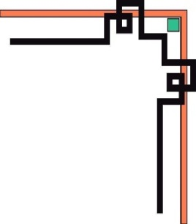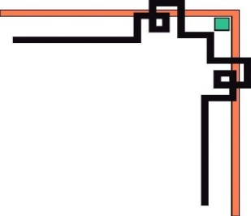

**DANANG SOFTWARE CORPORATION**

**SOFTECH-APTECH**



EProject :

Guiding faculty : TRINH THI THUY TIEN

Members :

* NGUYEN THI HONG NGOC
* VO THI HUYEN TRANG
* HUYNH QUOC HUY

Group: 03

Batch: 151

Project Document

**HISTORY MONUMENT**

|  |  |
| --- | --- |
| **Group 3** | |
| **Instructor** | Ms.Trinh Thi Thuy Tien |
| **Group Members** | Nguyen Thi Hong Ngoc (Leader)  Vo Thi Huyen Trang  Huynh Quoc Huy |
| **Batch** | 151 |
| **Semester** | 1 |

**TEACHER’S EVALUATION**

**Table of Contents**

I. ACKNOWLEDGEMENTS 4

II. INTRODUCTION 5

III. PROBLEM DEFINITION 5

**1.** **Homepage** 5

**2.** **Hi detail page** 5

**3.** **Login/Register information** 6

**4.** **Checkout information** 6

**6.** **News page** 7

**7.** **News detail page** 7

**8.** **About Us Page** 7

**9.** **Contac Us Page** 7

**10.** **Contact / Feedback** 8

IV. CRS & SITE MAP 8

1. Use case diagram 9

Use Case Specification 10

3. Layout 10

V. TECHNICAL 15

VI. REFERENCES 16

VII. GUI OF WEBSITE 17

Home page 17

VIII. CHECK LIST 34

1. Check List of Validation 34

2. Submission Checklist 34

IX.CONCLUTION…………………………………………………………………………………………………………………………..35

X.PROJECT PLANNING……………………………………………………………………………………………………………….…36

# I. ACKNOWLEDGEMENTS

We would like to sincerely acknowledge the kindness of all the people who have given moral support and helped us make a successful project.

We wish to express our deep gratitude to the e-Project Team at the Head office, who guided and helped us. Particular thanks to **Ms.Trinh Thi Thuy Tien** who suggested the “form validation” and help us connect storage to our project, develop the analysis proceeding from it and debugged code. We also would like to express our great gratitude to all the student members of our center (Softech Aptech).

Although we have made many attempts, because of the limited time, the practice could not be able to avoid the mistakes and missions. We hope that our project will be considered and evaluated. And finally, we would like to offer many thanks to all our friends for their valuable suggestions and constructive feedbacks.

# II. INTRODUCTION

# When visiting the monument, many visitors never knew, never heard of this place, so when the introduction team introduced about the birth, the process of existence and disintegration of the workers, all everyone is moved and mixed with admiration. Because only in a short period of time, this place witnessed many tragic but very heroic truths, illuminating the spirit of indomitable, persistent struggle of young revolutionary soldiers. Flip through each page of writing is growing more and more of the Book of Ideas, placed solemnly in the Traditional Room of the Monument, to feel all the respectful and dear feelings of visitors, especially of young people for this place.

Please join us to visit the famous historical monuments in the world that we selected through the Graduation History Monument project.

# III. PROBLEM DEFINITION

1. **Homepage**

The homepage will include a menu including subpages. Users can learn more. In addition, the homepage also briefly introduces the typical historical relics in the world. If you want to learn more, click on the link available next to each monument.

The home page also introduces the location of impressive monuments and architectures of monuments, construction quality and golden ratio of each historical monument. You can find it in the details page.

Finally, if you want to receive notifications from our company, please leave an email, we will update the latest information as well as the relevant historical relics in the world to your email.

1. **Product detail page**

For details page, you can find out more about historical information. You can view and read information, see vivid images. In addition, we also provide the location of historical monuments, convenient for your study to travel. More amazing, you can download that historical information by document version.

1. **Login/Register information**

When customers login, they have to fill out information on the form including: email and Password. They can also login with Facebook, Google+ or Twitter account.

If it is the first time for customers to access or visit website, they have to register before login. The register information includes full name, email, password and re-password.

1. **Checkout information**

When customer finished shopping, they have to fill out information on the form payments, including: name, email, address.

1. **News page**

The latest news are displayed in this pages. The latest news are showed in abbreviating form. If customers want to read full of articles, they click on button “read more”.

1. **News detail page**

History monument’ customers can read full information of articles which are showed in News page.

1. **About Us Page**

This page introduces our history, our mission, our vission, our core value.

1. **Contac Us Page**

This page includes us location on google map. Customers can send their message to us through Contact form.

1. **Contact / Feedback**

The development of technology era today, social network is a biggest social networks. Our website has functions connected with Facebook, YouTube, Twitter, etc… to help customers connect information and comment easily and faster.

# IV. CRS & SITE MAP

## Use case diagram

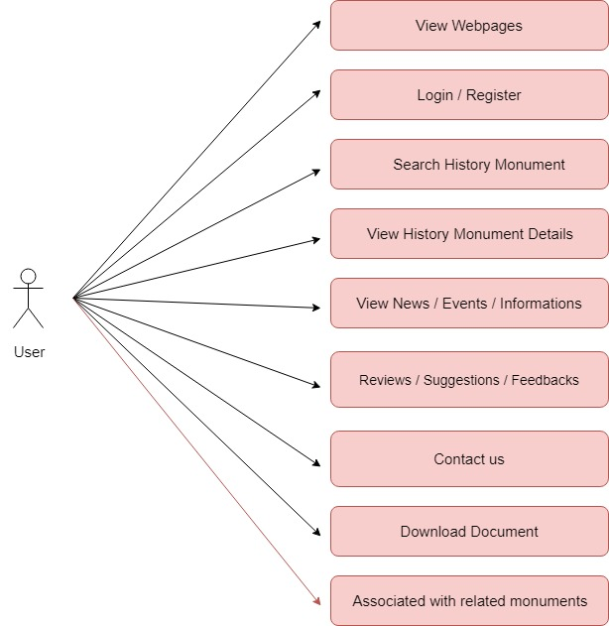

## Use Case Specification

|  |  |  |  |
| --- | --- | --- | --- |
| **USE CASE SPECIFICATION** | | | |
| **Use-case No.** | UC01 | **Use-case Version** | 1.0 |
| **Use-case Name** | *View Webpage* | | |
| **Purpose:**  Users can view historical monument, promotions, contacts, historical monument search, news search, about us, download file…  **Input:**  **Output:** | | | |

|  |  |  |  |
| --- | --- | --- | --- |
| **USE CASE SPECIFICATION** | | | |
| **Use-case No.** | UC02 | **Use-case Version** | 1.0 |
| **Use-case Name** | *Login/Register* | | |
| **Purpose:**  Users can view historical monument, promotions, contacts, historical monument search, news search, about us, download file…  **Input:**  Log in to save your product information, pick up the latest product information, promotions and points of sale.  Registered users can save your product information get the latest product information, promotions and point-of-sale.  **Output:**  Users used to exit the browser, application. | | | |

|  |  |  |  |
| --- | --- | --- | --- |
| **USE CASE SPECIFICATION** | | | |
| **Use-case No.** | UC03 | **Use-case Version** | 1.0 |
| **Use-case Name** | *Search historical monument* | | |
| **Purpose:**  A user can search for a historical monument of his choice by entering history name. Then a select query is used to retrieve data from the database and display the selected information.  **Input:**  The user will enter history name in a text box provided.  **Output:**  The system will display the history that matches the search criteria. | | | |
| **USE CASE SPECIFICATION** | | | |
| **Use-case No.** | UC04 | **Use-case Version** | 1.0 |
| **Use-case Name** | *View Historical Monument Details* | | |
| **Purpose:**  A user can view a product detail of his choice by selecting category, subcategory and history monument name. Then a select query is used to retrieve data from the database and display the selected information. Then user can download this file about the detail pages.  **Input:**  The user will select category, subcategory on the menus provided and select a history monument name on a data bound provided.  **Output:**  The system will display the historical monument that matches the selected criteria. | | | |

|  |  |  |  |
| --- | --- | --- | --- |
| **USE CASE SPECIFICATION** | | | |
| **Use-case No.** | UC05 | **Use-case Version** | 1.0 |
| **Use-case Name** | *View News* | | |
| **Purpose:**  Users could see every up-to-date information about the products and promotion.  **Input:**  **Output:** | | | |

|  |  |  |  |
| --- | --- | --- | --- |
| **USE CASE SPECIFICATION** | | | |
| **Use-case No.** | UC07 | **Use-case Version** | 1.0 |
| **Use-case Name** | *Contact/Feedback* | | |
| **Purpose:**  If the user wants to send a message or feedback for us then they need to to enter information  **Input:**  The user will enter details in the contact form according to there quire fields. The fields include :  1. Email  2. Subject  3. Message  **Output:**  Then the user will get the notification message that the feedback was send successfully and the page is refreshed.  **Input:**  The user will enter the quantity required and click button buy | | | |

|  |  |  |  |
| --- | --- | --- | --- |
| **USE CASE SPECIFICATION** | | | |
| **Use-case No.** | UC08 | **Use-case Version** | 1.0 |
| **Use-case Name** | *Compare* | | |
| **Purpose:**  User can compare Products. View information products  **Input:**  Select Product.  **Output:**  User can see information between 2 products and compare them. | | | |

**Site map**

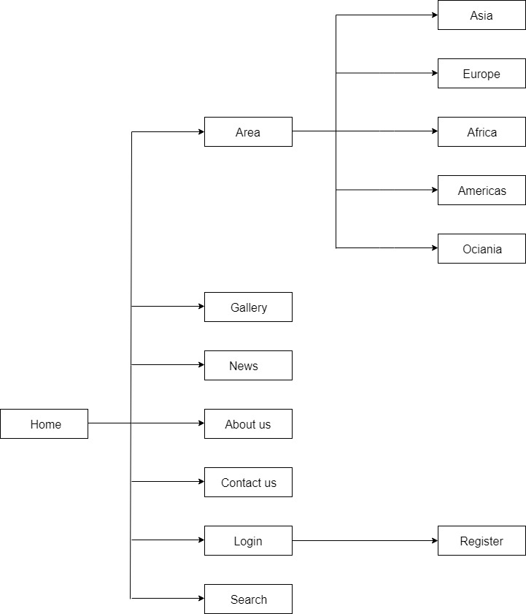

1. **Layout:**
2. 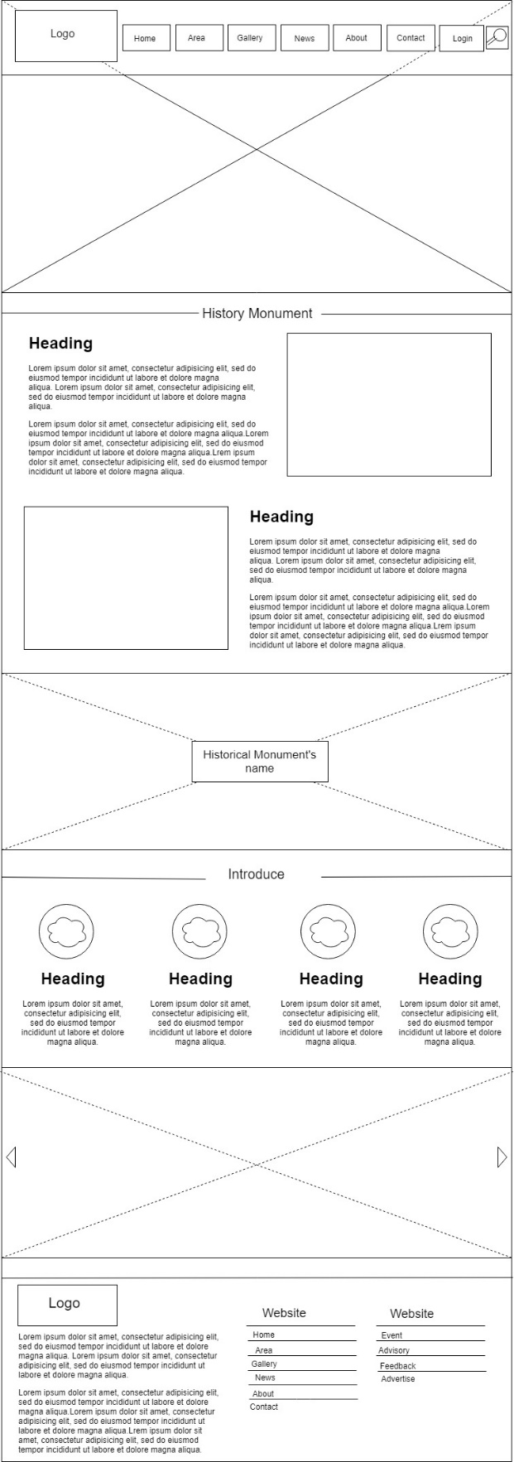

**Layout Home Page**

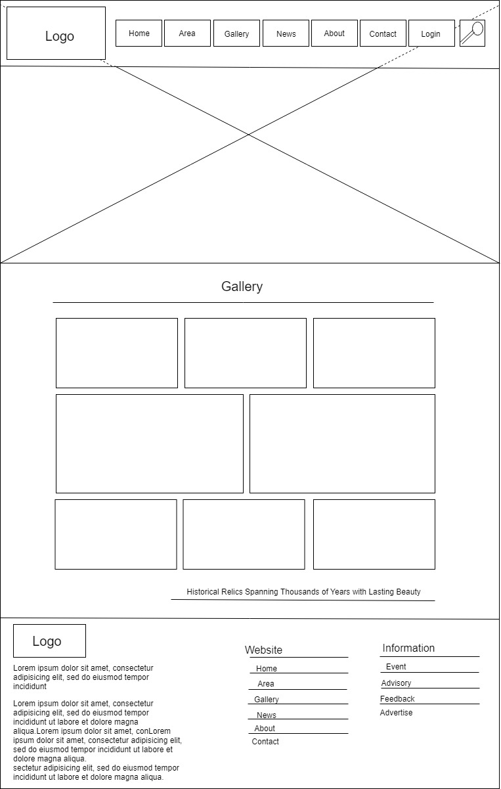

**Layout Gallery Page**

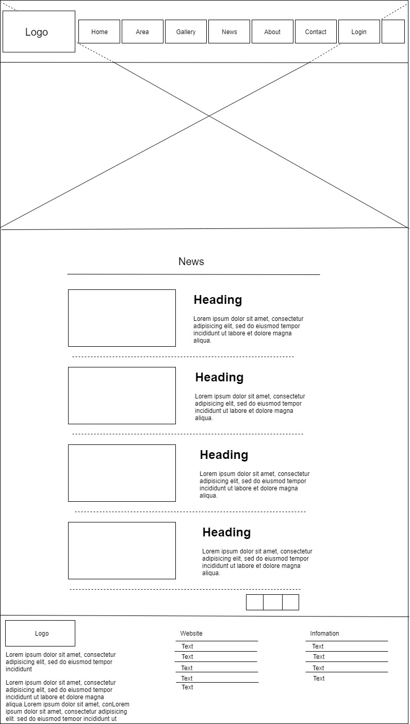

**Layout News Page**

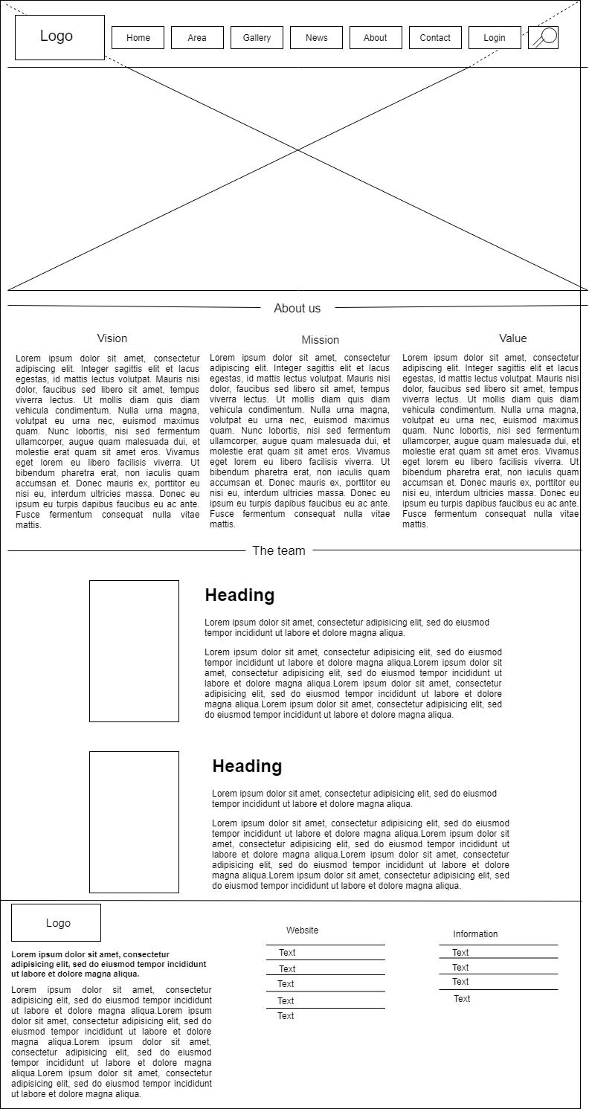

**Layout About us Page**

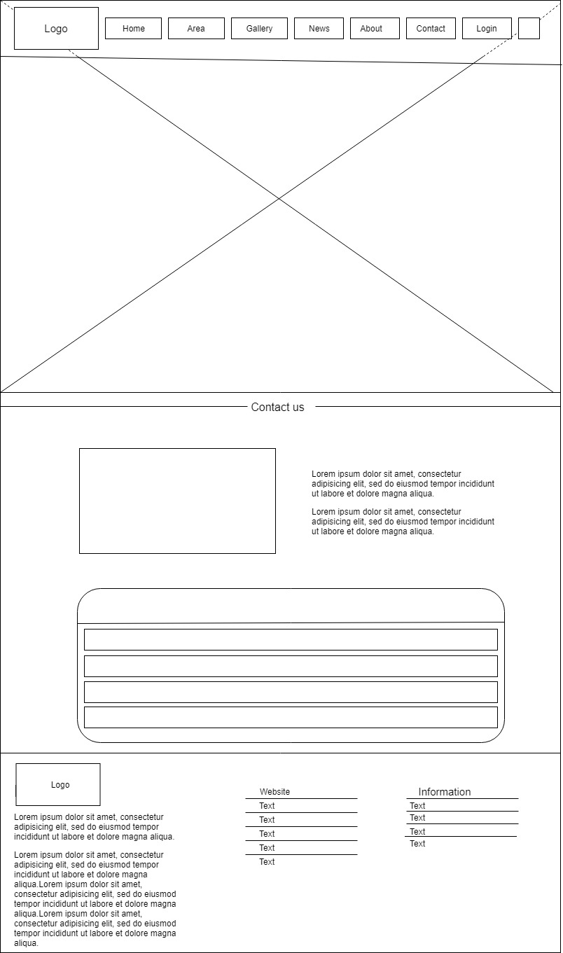

**Layout Contact Page**

# V. TECHNICAL

Software: WebStorm

Web Browser: Blisk, Chrome, Firefox support design Responsive

The technique used to build the Website:

* HTML5 & CSS3.
* Responsive Bootstrap
* Validation for bootstrap.
* JQuery & JavaScript.
* Local Storage
* Bootstrap form helpers.
* Horizontal fixed navigation.
* Fancybox JQuery
* Material for bootstrap:
* JS popover.
* JS Scrollspy.
* Modal.
* Tabs.
* BootStrap Carousel.
* Button.
* Table.
* Form.
* …….
* …….

# VI. REFERENCES

We consulted information on the websites:

* [**https://jquery.com/**](https://jquery.com/)
* [**http://www.w3schools.com/**](http://www.w3schools.com/)
* **http://www.getbootstrap.com/**VII. GUI OF WEBSITE

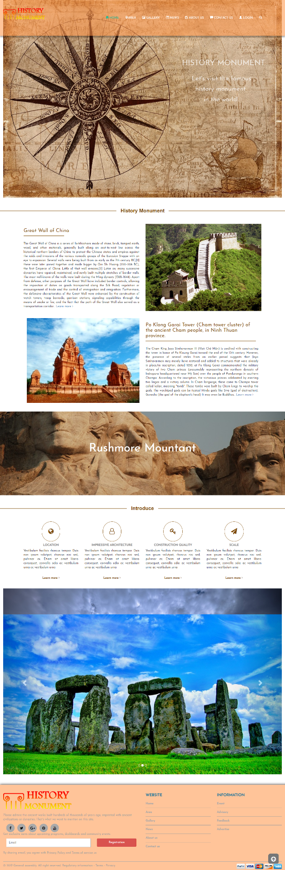  
**Home page**

# 

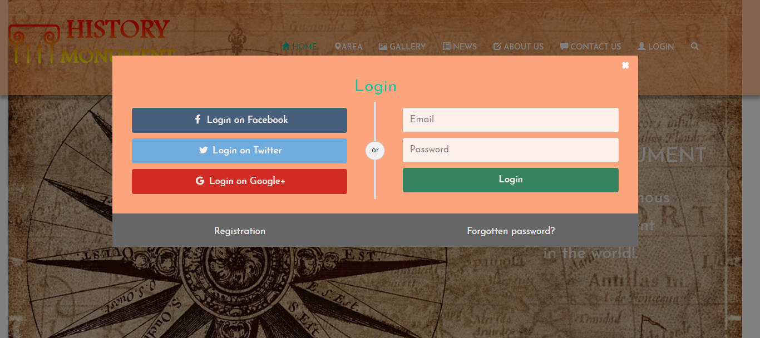**Login**

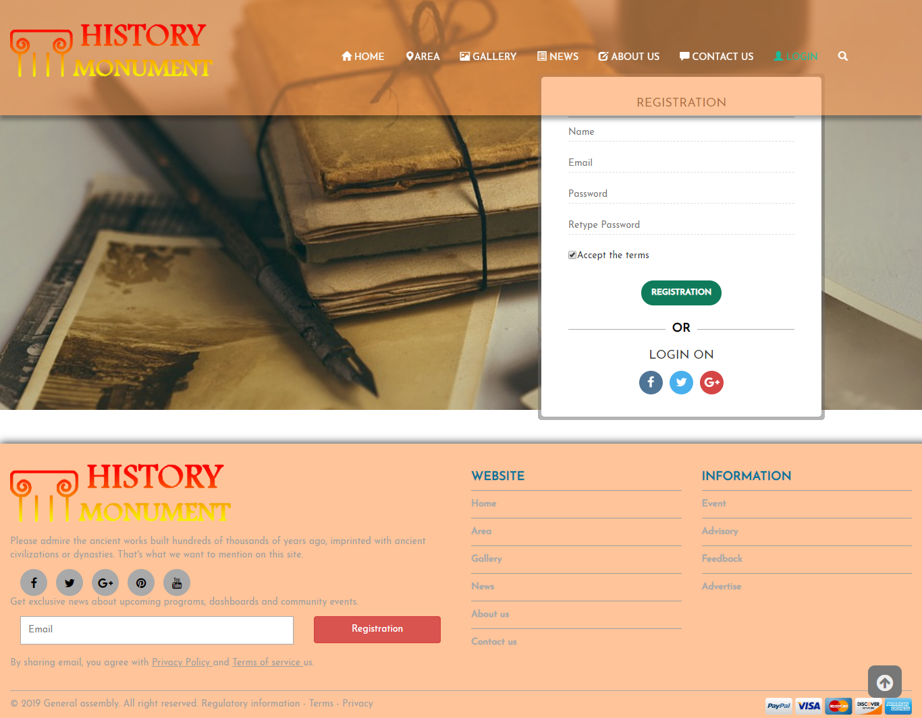

**Register**

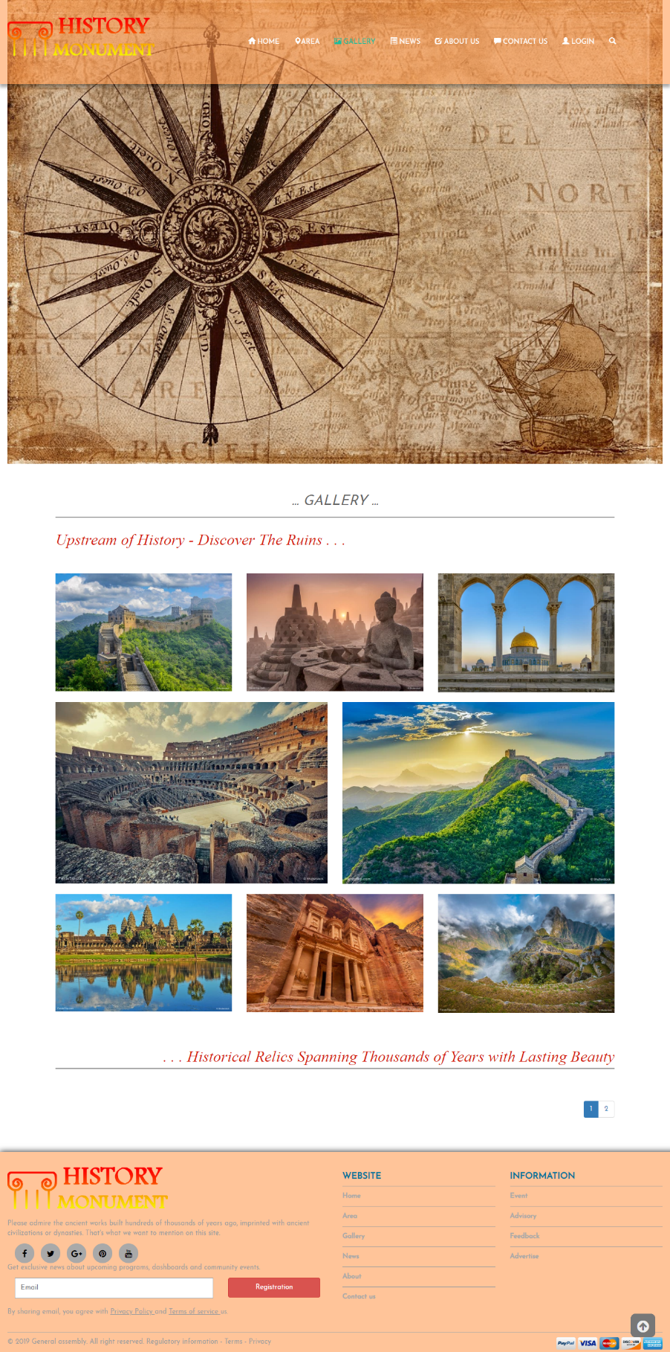

**Gallery**

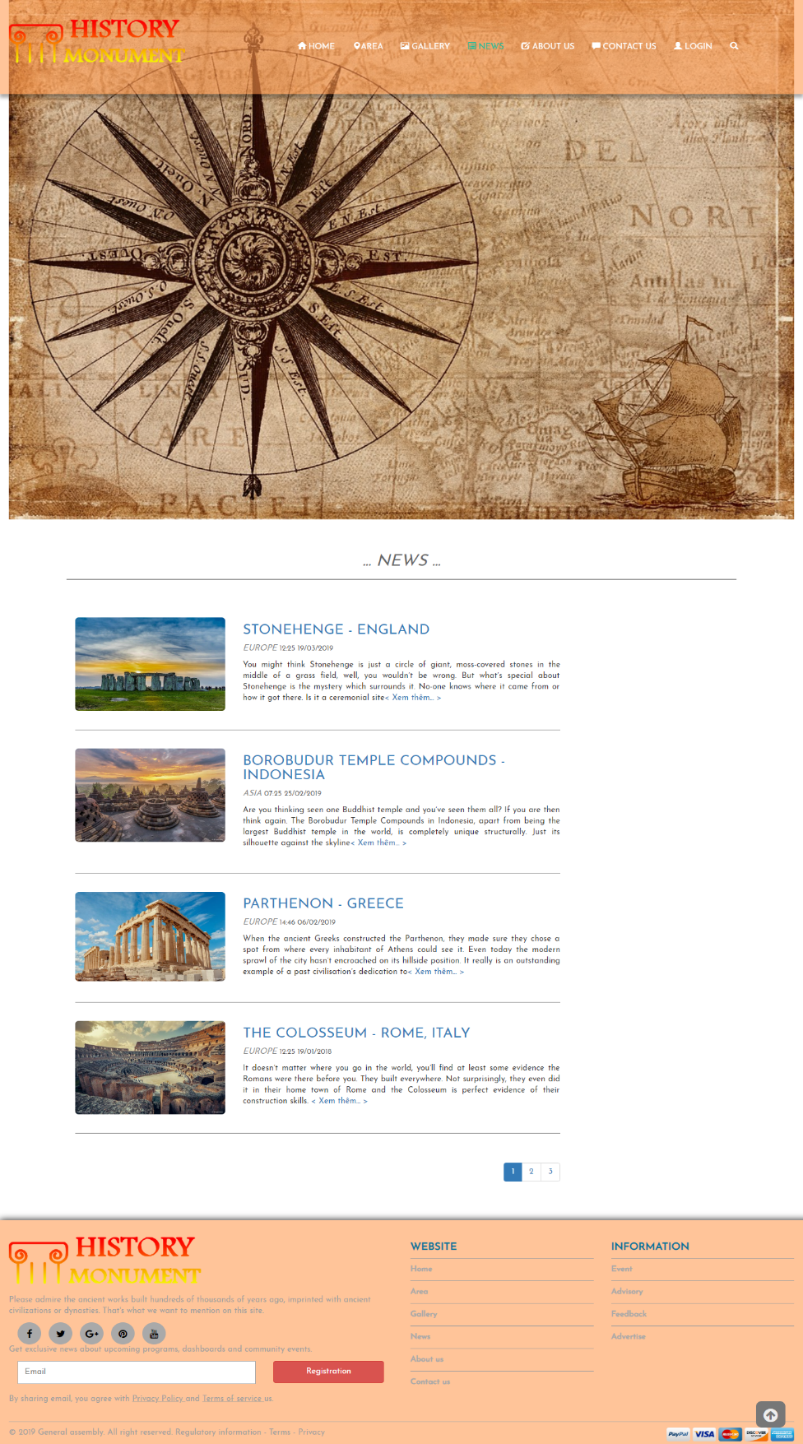

**News**

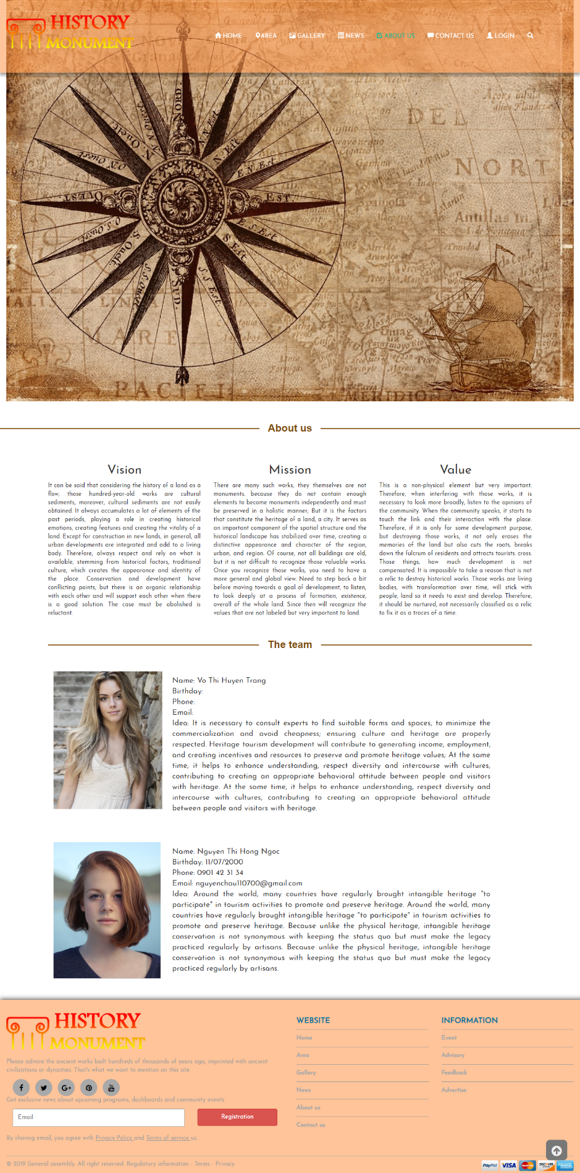

**About us pages**

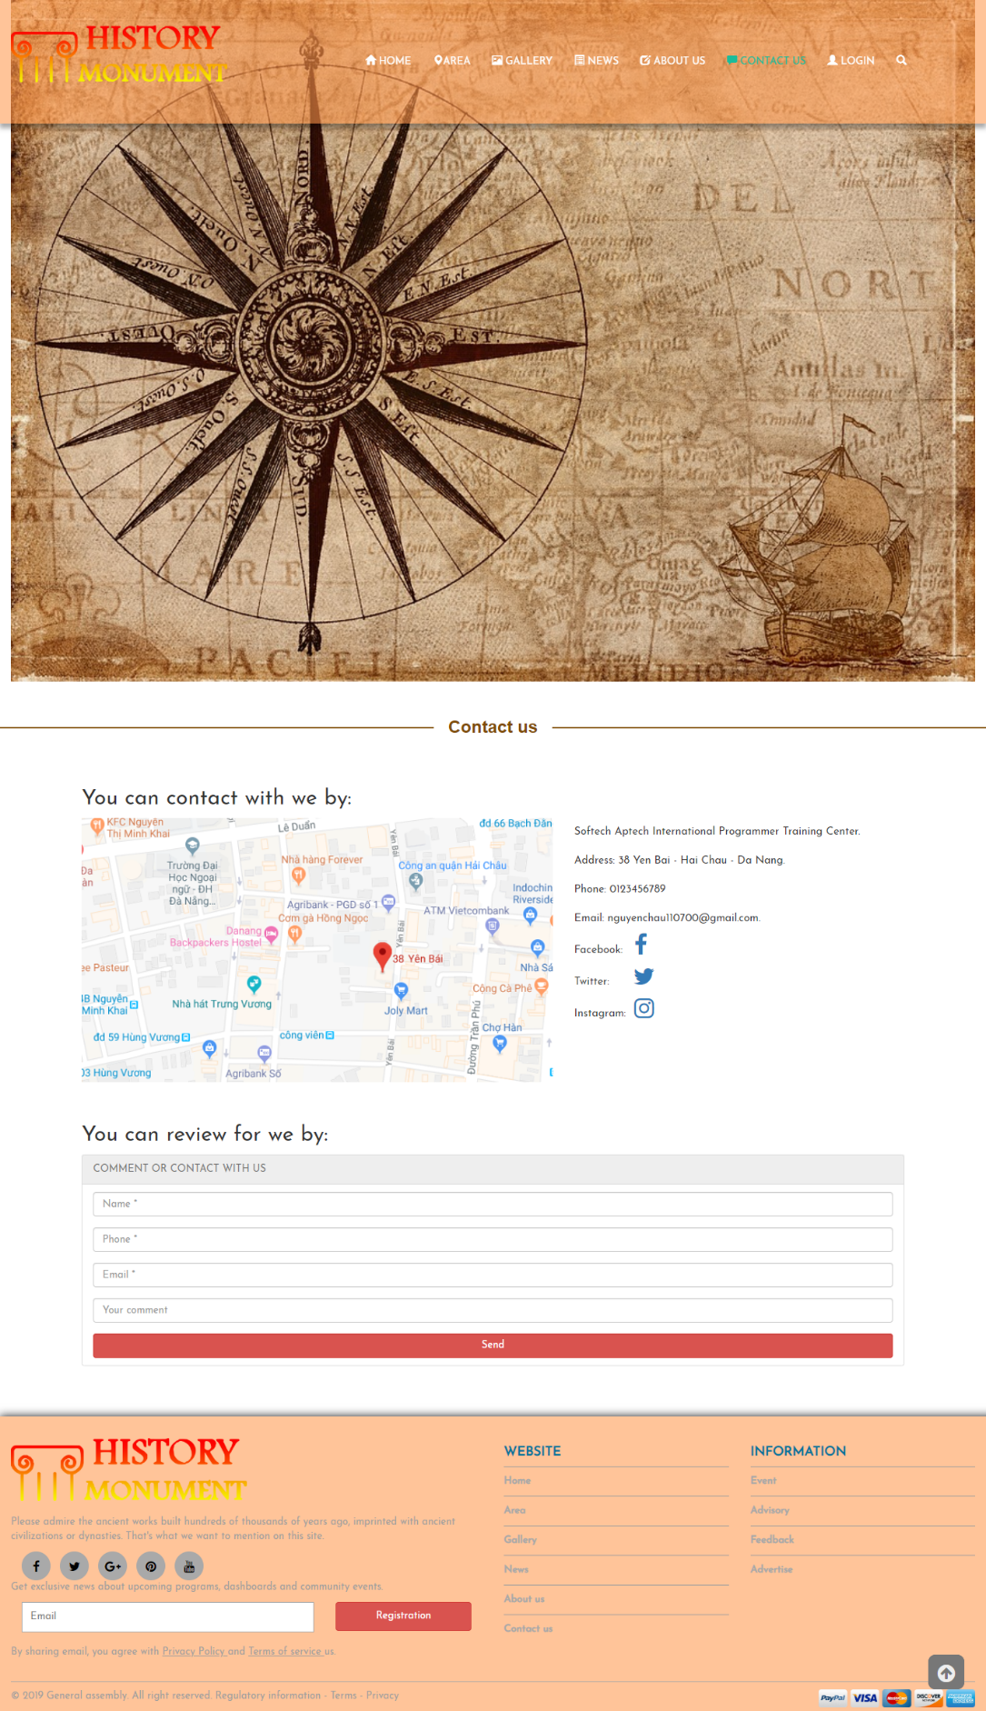

**Contact us Page**

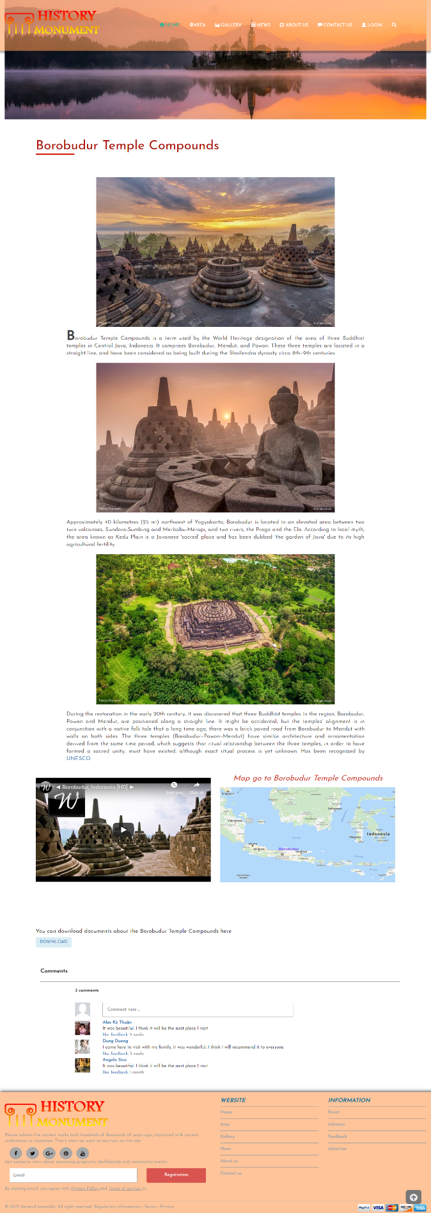

**Detail Page**

# VIII. CHECK LIST

## 1. Check List of Validation

|  |  |
| --- | --- |
| **Option** | **validate** |
| Has the hardware and software been correctly chosen? | Yes |
| Are there functions for the user to enter their comment | No |
| Do all the options present in the application display the correct result? | Yes |
| Are there functions cart? | No |
| Are there function for the user buy product? | No |

## 2. Submission Checklist

|  |  |  |  |  |  |
| --- | --- | --- | --- | --- | --- |
| **No.** | **Particulars** | **Yes** | **No** | **N/A** | **Comments** |
| 1 | Is the users table to login the Application on the user name and  Password? |  |  |  |  |
| 2 | Is there a form for users to enter  Personal information when buying |  |  |  |  |
| 3 | Can the user to edit employee’s details after getting added? |  |  |  |  |
| 4 | Is the user able to find a historical sites’s wherever they want? |  |  |  |  |
| 5 | Is the application user-friendly? |  |  |  | Windows GUI is familiar with everyone |

**IX. CONCLUTION**

Historical-Monuments website includes: Home page, Area, Gallery, News, About us, Contact us, Login/Register.

However, this website also need to be develop and upgrated.

Here is the development direction:

1. Complete or perfect remaing parts of this website
2. Change background image and color, font and other as required by the client
3. Develop mobile-optimized website with functions such as: [Website Responsive](https://www.mypage.vn/thiet-ke-web-theo-chuan-mobile.html), [Responsive Design](https://www.mypage.vn/thiet-ke-web-theo-chuan-mobile.html)…
4. Upgrate static website to dynamic website by using java, C#...
5. Build webApp.

# X. PROJECT PLANNING

|  |  |
| --- | --- |
| WORK | MEMBER |
| Navbar | Ngoc |
| Footer | Ngoc |
| Home page | Ngoc |
| Contact page | Ngoc |
| Editor website | Ngoc |
| Login/Registration Page | Ngoc |
| About us Page | Ngoc |
| Gallery page | Trang |
| Document | Trang, Ngoc |
| News page | Trang |
| Asia page | Trang |
| Europe page | Trang |
| Africa page | Trang |
| Americas page | Trang |
| Document download | Trang, Ngoc |